Hi Vincent,

First of all I learned today that the Conversion Library is already available for the U2B-E and can be delivered as part of the MCAL.
Means it would have some kind of quality, which definitely makes it worthwhile to propose to BYD.
@Toan Pham and @Phuong Nguyen can probably provide more insides.

Now to your questions. I completely understand why you are confused; I myself find it difficult to explain the exact differences.
RCP and SOME/IP are different approaches.
There have been feasibility projects to use SOME/IP to implement RCP.
But the conclusion was that it would be technically feasible, but SOME/IP would involve too much overhead.

Roughly speaking, SOME/IP is used to provide a service, whereby service here refers to a type of application.
For example, it could be a door module, and the central computer would use the service provided by the door module.
This means that the door module has the complete function locally and provides simple commands, e.g. open or close window.
In RCP concept the Door module application is located in the central computer.
And would send PWM messages via RCP to the Door module where the actual stepper motor is then controlled.
(this is a very high level abstraction, as window lifter probably would require local safety measures for anti-pinch protection)

Technically you can achieve the same, but in the RCP concept you would be faster for maintenance or updates and would be independent of the door module manufacture.
But it is a complete different concepts and the question is which concepts is preferred by the OEM.

Therefore, the need of routing accelerators will continue, but at the same time, the demand for RCP will increase.
I once tried to explain the differences, but I didn't really succeed.
But I'm attaching the document anyway, maybe it will help you clear up your confusion.

To complete I added a answer to the question below; please check below.

Best Regards
Tobias

From: Vincent Lin <vincent.lin.ud@renesas.com>
Sent: Donnerstag, 22. Januar 2026 08:16
To: Tobias Belitz <tobias.belitz@renesas.com>; Ricky Aer <ricky.aer.yb@renesas.com>; Costas Rente <costas.rente@renesas.com>; Yi Guo <yi.guo@renesas.com>; Toan Pham <toan.pham.px@renesas.com>; Phuong Nguyen <phuong.nguyen.pz@renesas.com>
Cc: Kun Zhao <kun.zhao.vx@renesas.com>; Shelford Zhu <shelford.zhu.ak@renesas.com>; Elva Wang <elva.wang.uj@renesas.com>; Song Liu <song.liu.ux@renesas.com>; Jing Yan <jing.yan.wh@renesas.com>; Mark Ma <mark.ma.eb@renesas.com>; Nico Mo <nico.mo.sx@renesas.com>; Gaowei Li <gaowei.li.jg@renesas.com>; Jianfeng Wang <jianfeng.wang.wg@renesas.com>; Sam Gold <Sam.Gold@renesas.com>; Thorsten Hoffleit <thorsten.hoffleit@renesas.com>
Subject: RE: [routine performance on U2Bx-E]RE: Inquiry on Device Recommendations and Plans for BYD IO Aggregator (EEA 5.0)

Hello Tobias Belitz

Thanks again for the detailed explanation and the RCP presentation.
After reviewing your slides and updating my diagrams, I realized that I may still misunderstand one key point, and I would like to confirm it with you.

1. My current understanding
I now understand that RCP does not remove interfaces such as CAN, 10BASE-T1S, SPI, I2C or GPIO from the system.
These interfaces are still required because:
- SPI/I2C/GPIO cannot be extended over long distances in a vehicle
- Therefore actuators and sensors cannot be driven directly through SPI/I2C/IO from the I/O Aggregator
- Most actuators will still need either a small MCU or a local bus such as CAN or T1S
So RCP mainly changes the I/O Aggregator layer, not the physical execution layer.
Is this assumption correct?
TBE: Basically yes
But RCP should not be treated as tunnel protocol. Where a SPI, or LIN frame is tunneled 1to1,
it is more a functional communication using SPI or LIN data.

2. What still confuses me
If actuators still require CAN/T1S and, in many cases, a small MCU for timing/safety control, then the edge execution layer looks very similar between RCP and SOME/IP.
This leads to my question:
What is the fundamental system-level benefit of RCP compared to a SOME/IP-based architecture, since both still require the I/O Aggregator to forward signals to actuators over CAN/T1S?
From my perspective today:
- RCP affects mainly the communication format between HPC and the I/O Aggregator
- The lower execution layer still depends on CAN/T1S/MCU
- For complex modules (SBW/EMB), an MCU is required in both RCP and SOME/IP systems
- For simpler modules, RCP still cannot use SPI/I2C/IO directly due to wiring limitations
So I want to confirm whether my understanding is correct, or if I am missing an important benefit of RCP.
TBE: Yes RCP and SOME/IP looks similar refer to explanation above.

3. Request for review of my updated diagrams
I updated both diagrams (RCP version and SOME/IP version) to reflect my current understanding.
Could you please check if these differences are accurate?
This would help me explain the concept more clearly to BYD as well.
TBE: I am not sure if this drawing shows the actual difference, I created a different version see attached document.
But to be honest it does not illustrate the difference better.

Figure 1:
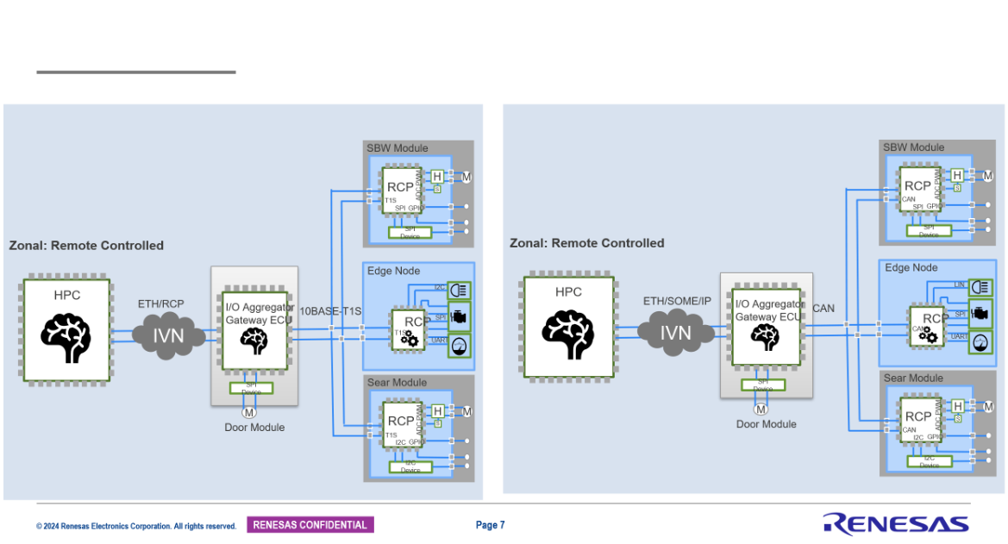

Thanks again for your support.
I really appreciate the clarification.

Best regards,
Vincent Lin;

From: Tobias Belitz <tobias.belitz@renesas.com>
Sent: Wednesday, January 21, 2026 6:40 PM
To: Vincent Lin <vincent.lin.ud@renesas.com>; Ricky Aer <ricky.aer.yb@renesas.com>; Costas Rente <costas.rente@renesas.com>; Yi Guo <yi.guo@renesas.com>; Toan Pham <toan.pham.px@renesas.com>; Phuong Nguyen <phuong.nguyen.pz@renesas.com>
Cc: Kun Zhao <kun.zhao.vx@renesas.com>; Shelford Zhu <shelford.zhu.ak@renesas.com>; Elva Wang <elva.wang.uj@renesas.com>; Song Liu <song.liu.ux@renesas.com>; Jing Yan <jing.yan.wh@renesas.com>; Mark Ma <mark.ma.eb@renesas.com>; Nico Mo <nico.mo.sx@renesas.com>; Gaowei Li <gaowei.li.jg@renesas.com>; Jianfeng Wang <jianfeng.wang.wg@renesas.com>; Sam Gold <Sam.Gold@renesas.com>; Thorsten Hoffleit <thorsten.hoffleit@renesas.com>
Subject: RE: [routine performance on U2Bx-E]RE: Inquiry on Device Recommendations and Plans for BYD IO Aggregator (EEA 5.0)

Hi Vincent,

Thanks for the explanation. I understand that the current solution is not exactly an "out-of-the-box" feature, particularly from a quality standpoint.
It seems like the software we have is just an example and BYD is looking for more production-grade software.
Renesas should perhaps consider developing and selling this as a production software, especially since NXP appears to be actively pursuing this strategy.

The term "I/O aggregator" is indeed used in different ways today. In Honda's case, it involves transferring information from CAN, LIN, or GPIO via Ethernet,
with the application remaining in the edge nodes. Here, the I/O Aggregator handles the forwarding logic, requiring significant processing power.
On the other hand, when others refer to an I/O Aggregator between the central computer and the edge ECU, they are talking about the new Remote Control Protocol (RCP).
In this scenario, the edge is remotely controlled from the central computer where the application is running,
and the I/O Aggregator functions is a simple switching device since all information are already encapsulated in Ethernet frames.
However, this is more of a future outlook since the RCP is still in the definition phase.

In any case, we are very interested in the view of Chinese OEMs. Since the China market reacts much more quickly to innovations than the rest of the world.
Could you please check their future views on this, in particular RCP?
I have recently given an introduction to RCP, and the presentation was recorded.
You can view it here (time code: 1:09:18):
https://renesasgroup.sharepoint.com/sites/abu-an/sitepages/2025--12-communication-technology-liaison-group-meeting.aspx?web=1

Best regards,
Tobias

From: Vincent Lin <vincent.lin.ud@renesas.com>
Sent: Mittwoch, 21. Januar 2026 10:44
To: Tobias Belitz <tobias.belitz@renesas.com>; Ricky Aer <ricky.aer.yb@renesas.com>; Costas Rente <costas.rente@renesas.com>; Yi Guo <yi.guo@renesas.com>; Toan Pham <toan.pham.px@renesas.com>; Phuong Nguyen <phuong.nguyen.pz@renesas.com>
Cc: Kun Zhao <kun.zhao.vx@renesas.com>; Shelford Zhu <shelford.zhu.ak@renesas.com>; Elva Wang <elva.wang.uj@renesas.com>; Song Liu <song.liu.ux@renesas.com>; Jing Yan <jing.yan.wh@renesas.com>; Mark Ma <mark.ma.eb@renesas.com>; Nico Mo <nico.mo.sx@renesas.com>; Gaowei Li <gaowei.li.jg@renesas.com>; Jianfeng Wang <jianfeng.wang.wg@renesas.com>; Sam Gold <Sam.Gold@renesas.com>; Thorsten Hoffleit <thorsten.hoffleit@renesas.com>
Subject: RE: [routine performance on U2Bx-E]RE: Inquiry on Device Recommendations and Plans for BYD IO Aggregator (EEA 5.0)

Hello Tobias Belitz

Thank you for your comments.
Let me clarify what I mean by “complete.”
When I say the implementation is not “complete,” I do not mean that the API functions are missing.
I mean that customers expect a ready-to-run forwarding logic.
BYD does not want to write the unpacking, routing, and forwarding code by themselves.
What they want is similar to a CAN-to-CAN gateway function provided as part of the RH850 platform, where they only need to configure routing rules,
and the hardware/software can forward frames automatically with minimal maintenance effort.
This is why I say:
API ≠ a production-ready gateway solution.
In addition, BYD is looking for hardware-accelerated or hardware-fixed forwarding behavior, not a pure software API that still requires them to implement the forwarding logic on their own.
Regarding the missing detailed requirements from BYD: yes, this makes the definition more difficult, because the customer is not willing to share more details due to internal reasons. So we can only describe “complete” based on their general expectation for an out-of-box gateway behavior.
I agree with you that the current API is still useful for further discussion, since we do not have a better alternative at this moment.
And involving the Vietnam colleagues is also a good suggestion.

By the way, I am also curious about Honda’s use case.
I saw the I/O Aggregator information in the marketing material, and it shows that Honda, Nissan, and GM all use the I/O Aggregator architecture.
Do you know what their requirements are for the I/O Aggregator between the central computer and the edge ECU?
My understanding is that they should also have requirements for Ethernet-to-CAN forwarding throughput.
Or is it because their integration level is lower, so the CAN traffic volume is not very high?

Best regards,
Vincent Lin;

From: Tobias Belitz <tobias.belitz@renesas.com>
Sent: Wednesday, January 21, 2026 5:20 PM
To: Vincent Lin <vincent.lin.ud@renesas.com>; Ricky Aer <ricky.aer.yb@renesas.com>; Costas Rente <costas.rente@renesas.com>; Yi Guo <yi.guo@renesas.com>
Cc: Kun Zhao <kun.zhao.vx@renesas.com>; Shelford Zhu <shelford.zhu.ak@renesas.com>; Elva Wang <elva.wang.uj@renesas.com>; Song Liu <song.liu.ux@renesas.com>; Jing Yan <jing.yan.wh@renesas.com>; Mark Ma <mark.ma.eb@renesas.com>; Nico Mo <nico.mo.sx@renesas.com>; Gaowei Li <gaowei.li.jg@renesas.com>; Jianfeng Wang <jianfeng.wang.wg@renesas.com>; Sam Gold <Sam.Gold@renesas.com>; Thorsten Hoffleit <thorsten.hoffleit@renesas.com>
Subject: RE: [routine performance on U2Bx-E]RE: Inquiry on Device Recommendations and Plans for BYD IO Aggregator (EEA 5.0)

Hi Vincent,

Just saw this email when hit the send button 😊

Please contact:
Toan Pham toan.pham.px@renesas.com
Phuong Nguyen <phuong.nguyen.pz@renesas.com>

BR
Tobias

From: Tobias Belitz tobias.belitz@renesas.com
Sent: Wednesday, January 21, 2026 5:17 PM
To: Vincent Lin vincent.lin.ud@renesas.com; Ricky Aer ricky.aer.yb@renesas.com; Costas Rente costas.rente@renesas.com; Yi Guo yi.guo@renesas.com
Cc: Kun Zhao kun.zhao.vx@renesas.com; Shelford Zhu shelford.zhu.ak@renesas.com; Elva Wang elva.wang.uj@renesas.com; Song Liu song.liu.ux@renesas.com; Jing Yan jing.yan.wh@renesas.com; Mark Ma mark.ma.eb@renesas.com; Nico Mo nico.mo.sx@renesas.com; Gaowei Li gaowei.li.jg@renesas.com; Jianfeng Wang jianfeng.wang.wg@renesas.com; Sam Gold Sam.Gold@renesas.com; Thorsten Hoffleit thorsten.hoffleit@renesas.com
Subject: RE: [routine performance on U2Bx-E]RE: Inquiry on Device Recommendations and Plans for BYD IO Aggregator (EEA 5.0)

Hi Vincent,

Maybe I misunderstand you comments, but I do not understand following comment.
“it does not provide a complete forwarding implementation”

Manly what does mean complete?
Further you mentioned “the customer is not willing to share more details at this moment”
How can we define what does mean complete, without the detailed information?

In general the the API “Protocol conversion” is supporting multiple interface and direction also Eth to CAN.
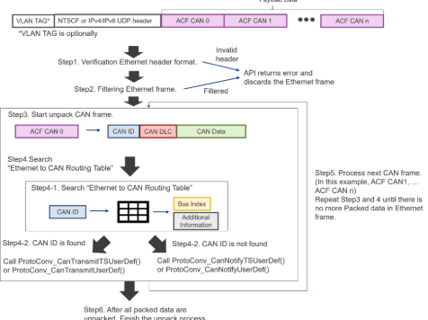

Anyway It is not the ideal solution but I think it can be used at least to continue the discussion with BYD based on this,
since I am not aware about any better solution at this moment.
As mentioned at the Jira ticket for API details it would be probably good to include the colleges from Vietnam

Just a comment from my side
BR
Tobias

From: Vincent Lin <vincent.lin.ud@renesas.com>
Sent: Mittwoch, 21. Januar 2026 10:10
To: Ricky Aer <ricky.aer.yb@renesas.com>; Costas Rente <costas.rente@renesas.com>; Yi Guo <yi.guo@renesas.com>; Tobias Belitz <tobias.belitz@renesas.com>
Cc: Kun Zhao <kun.zhao.vx@renesas.com>; Shelford Zhu <shelford.zhu.ak@renesas.com>; Elva Wang <elva.wang.uj@renesas.com>; Song Liu <song.liu.ux@renesas.com>; Jing Yan <jing.yan.wh@renesas.com>; Mark Ma <mark.ma.eb@renesas.com>; Nico Mo <nico.mo.sx@renesas.com>; Gaowei Li <gaowei.li.jg@renesas.com>; Jianfeng Wang <jianfeng.wang.wg@renesas.com>; Sam Gold <Sam.Gold@renesas.com>; Thorsten Hoffleit <thorsten.hoffleit@renesas.com>
Subject: RE: [routine performance on U2Bx-E]RE: Inquiry on Device Recommendations and Plans for BYD IO Aggregator (EEA 5.0)

Hello Costas Rente,Tobias Belitz，

Thanks for the material you shared.
Regarding the teams you mentioned (SW&D, SVCS, SVMB, SVMB3), could you let me know which specific team or contact person I should reach out to?

Hello Ricky,
1、I reviewed what Costas provided to Honda. The delivery only includes the API interfaces.
The software provides basic protocol conversion APIs, but it does not include any Ethernet-to-CAN forwarding logic. It does not include routing table handling, scheduling, or any fast-forward mechanism.
In short, the library is only an API layer, and it does not provide a complete forwarding implementation.
If we only provide these APIs and expect the customer to build the full ETH→CAN forwarding by themselves, BYD will not accept it. They need a working and verifiable solution, not only an empty set of APIs.

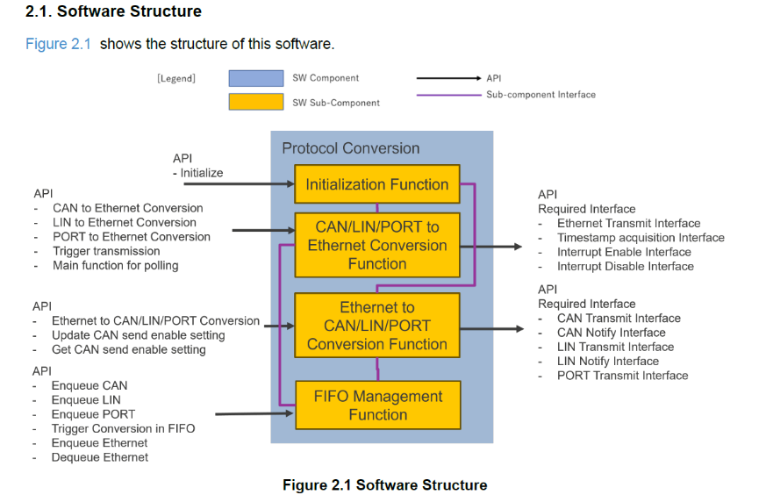

2、What specific information do you need?
Due to BYD’s internal management issues, the customer is not willing to share more details at this moment, so the available information is very limited.

Best regards,
Vincent Lin;

From: Ricky Aer <ricky.aer.yb@renesas.com>
Sent: Tuesday, January 20, 2026 10:47 AM
To: Vincent Lin <vincent.lin.ud@renesas.com>; Costas Rente <costas.rente@renesas.com>; Yi Guo <yi.guo@renesas.com>; Tobias Belitz <tobias.belitz@renesas.com>
Cc: Kun Zhao <kun.zhao.vx@renesas.com>; Shelford Zhu <shelford.zhu.ak@renesas.com>; Elva Wang <elva.wang.uj@renesas.com>; Song Liu <song.liu.ux@renesas.com>; Jing Yan <jing.yan.wh@renesas.com>; Mark Ma <mark.ma.eb@renesas.com>; Nico Mo <nico.mo.sx@renesas.com>; Gaowei Li <gaowei.li.jg@renesas.com>; Jianfeng Wang <jianfeng.wang.wg@renesas.com>; Sam Gold <Sam.Gold@renesas.com>; Thorsten Hoffleit <thorsten.hoffleit@renesas.com>
Subject: [routine performance on U2Bx-E]RE: Inquiry on Device Recommendations and Plans for BYD IO Aggregator (EEA 5.0)

Hello Costas,

Thanks for your kind support yesterday for the routine performance topic, BYD requested HW routine accelerator while we don’t have yet, so we’re try to convince with routine which CPU core, but need detail performance and benchmark, so we already made below JIRA ticket and try to get PG support how special routing software on CPU and the benchmark, not sure if it will be directly assigned to Mr. Tobias or not, please @Tobias Belitz could you comment below JARA which should be same situation you and your team have supported in other OEM case.

https://onefieldjira.renesas.com/browse/MCU-15516.

Hello Vincent,

Please try to learn BYD detail routine performance data requirements.
Thank you!

Best Regards,
Ricky AER
MCU Marketing, HPC High Performance Computing Product Group
Mobile: +86-15818692769
E-mail: ricky.aer.yb@renesas.com

Renesas Electronics
www.Renesas.com

From: Vincent Lin <vincent.lin.ud@renesas.com>
Sent: Tuesday, January 20, 2026 10:24 AM
To: Ricky Aer <ricky.aer.yb@renesas.com>
Cc: Kun Zhao <kun.zhao.vx@renesas.com>; Shelford Zhu <shelford.zhu.ak@renesas.com>; Elva Wang <elva.wang.uj@renesas.com>; Song Liu <song.liu.ux@renesas.com>; Jing Yan <jing.yan.wh@renesas.com>; Mark Ma <mark.ma.eb@renesas.com>; Nico Mo <nico.mo.sx@renesas.com>; Gaowei Li <gaowei.li.jg@renesas.com>; Jianfeng Wang <jianfeng.wang.wg@renesas.com>
Subject: RE: Inquiry on Device Recommendations and Plans for BYD IO Aggregator (EEA 5.0)

Hello Ricky,

2.However, we have one case from global OEM that also mentioned routine HW accelerator to PG before, our technical team have made special routing software on CPU to convince the OEM, that is without routing HW acc but can reach the OEM desired performance. For BYD case, I think we can also try this way, as mentioned in this morning meeting, please make a JIRA ticket to request detail technical solution based on routing with CPU core, please Jianfeng comment if any.
cm：Here is the JIRA link regarding the HW Accelerator. I have already submitted the request:
https://onefieldjira.renesas.com/browse/MCU-15516.
Was the previous OEM case based on an I/O Aggregator architecture?My understanding is that the requirement for a HW Accelerator differs significantly between I/O Aggregators and Zone Controllers.
Could you please share more details about the previous OEM case?
1)How was the routing implemented purely in software on the CPU?
2)How many cores were used and what was the typical CPU load?
3)Was zero-copy, queue optimization, or cache optimization involved?
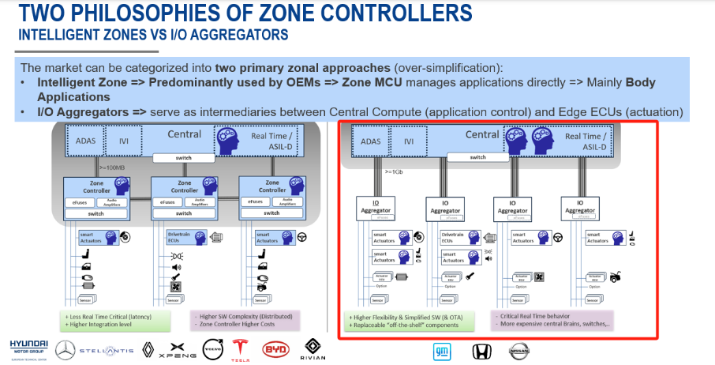

4.For detail part we proposed, even below requirements have some changes vs previous one, but because the requirements are >=3+1 core 350MHz, CANXL, 1.65MB RAM, so I think it still U2B16-E, further more we can try U2B12-E which is better on core number(4+2) and flash, but 1.4MB RAM has few GAP vs 1.65MB(1.38*1.2， actually they just needs 1.38MB right? Other 20% is for reserved)
cm：The customer selected the device based on a 1.65MB RAM requirement. For automotive MCU selection, it is common that customers reserve additional RAM and ROM margin on top of the actual requirement.
In this case, their real usage is around 1.38MB, and the remaining ~20% is reserved.
At this stage, the key issue remains whether a HW Accelerator is required, because performing routing purely on the CPU may occupy several cores, which will directly affect the number of usable cores and our final device recommendation.

Best regards,
Vincent Lin;

From: Ricky Aer <ricky.aer.yb@renesas.com>
Sent: Monday, January 19, 2026 5:44 PM
To: Vincent Lin <vincent.lin.ud@renesas.com>
Cc: Kun Zhao <kun.zhao.vx@renesas.com>; Shelford Zhu <shelford.zhu.ak@renesas.com>; Elva Wang <elva.wang.uj@renesas.com>; Song Liu <song.liu.ux@renesas.com>; Jing Yan <jing.yan.wh@renesas.com>; Mark Ma <mark.ma.eb@renesas.com>; Nico Mo <nico.mo.sx@renesas.com>; Gaowei Li <gaowei.li.jg@renesas.com>; Jianfeng Wang <jianfeng.wang.wg@renesas.com>
Subject: RE: Inquiry on Device Recommendations and Plans for BYD IO Aggregator (EEA 5.0)

Hello Vincent,

Thanks for your summary !
- We talked to PG MKT team this afternoon, for routine HW accelerator, planned on U5H series, like U5H8 which is the closest part for the requirements, but of course the schedule is not now. no routine HW accelerator on U5M
- However, we have one case from global OEM that also mentioned routine HW accelerator to PG before, our technical team have made special routing software on CPU to convince the OEM, that is without routing HW acc but can reach the OEM desired performance. For BYD case, I think we can also try this way, as mentioned in this morning meeting, please make a JIRA ticket to request detail technical solution based on routing with CPU core, please Jianfeng comment if any.
- Also we listed some questions to Mark this morning for let’s detail check with BYD, can they detail clarify their routine performance data, so that we can detail test and provide the results for their reference.
- For detail part we proposed, even below requirements have some changes vs previous one, but because the requirements are >=3+1 core 350MHz, CANXL, 1.65MB RAM, so I think it still U2B16-E, further more we can try U2B12-E which is better on core number(4+2) and flash, but 1.4MB RAM has few GAP vs 1.65MB(1.38*1.2， actually they just needs 1.38MB right? Other 20% is for reserved)

Best Regards,
Ricky AER
MCU Marketing, HPC High Performance Computing Product Group
Mobile: +86-15818692769
E-mail: ricky.aer.yb@renesas.com

Renesas Electronics
www.Renesas.com

From: Vincent Lin <vincent.lin.ud@renesas.com>
Sent: Monday, January 19, 2026 4:40 PM
To: Ricky Aer <ricky.aer.yb@renesas.com>
Cc: Kun Zhao <kun.zhao.vx@renesas.com>; Shelford Zhu <shelford.zhu.ak@renesas.com>; Elva Wang <elva.wang.uj@renesas.com>; Song Liu <song.liu.ux@renesas.com>; Jing Yan <jing.yan.wh@renesas.com>; Mark Ma <mark.ma.eb@renesas.com>; Nico Mo <nico.mo.sx@renesas.com>
Subject: Inquiry on Device Recommendations and Plans for BYD IO Aggregator (EEA 5.0)

Hello Ricky，

BYD is moving toward their EEA 5.0 architecture and will adopt an IO Aggregator–based design (ref. Figure 1).
Unlike their previous ZCU-based zonal architecture, the IO Aggregators sit between the central compute and edge ECUs, handling communication, signal aggregation, and protocol routing.

Their IO Aggregator requirements are summarized in Figure 2.
The key mandatory points include:
- Native CAN→Ethernet and Ethernet→CAN routing, provided out-of-factory
- Implementation must be official and production-grade
(software-core + standard HW-assist is acceptable; customer-developed or simulated routing is not accepted)
- CPU ≥ 350 MHz, SRAM ≥ 1.65 MB, Flash ≥ 3.2 MB
- 10× CAN FD, 1× CAN XL, 1× Ethernet
- Rich peripheral sets (I²C, SPI, PWM, ADC, etc.)
- Audio (TDM8 / TDM16) and ≥ ASIL-B

I would like to check internally whether we have:
- Any recommended devices, besides U2B_E, that can meet or partially meet these IO Aggregator requirements.
- Any product plans or roadmap items specifically addressing IO Aggregator / zonal gateway roles for EEA 5.0 (ex:RCAR-U5??)(especially for China OEMs).
Any inputs or references would be very helpful.

The BYD customer's architecture and requirements have changed, and this is their latest update: https://onefieldjira.renesas.com/browse/MCU-15516.

Figure 1:
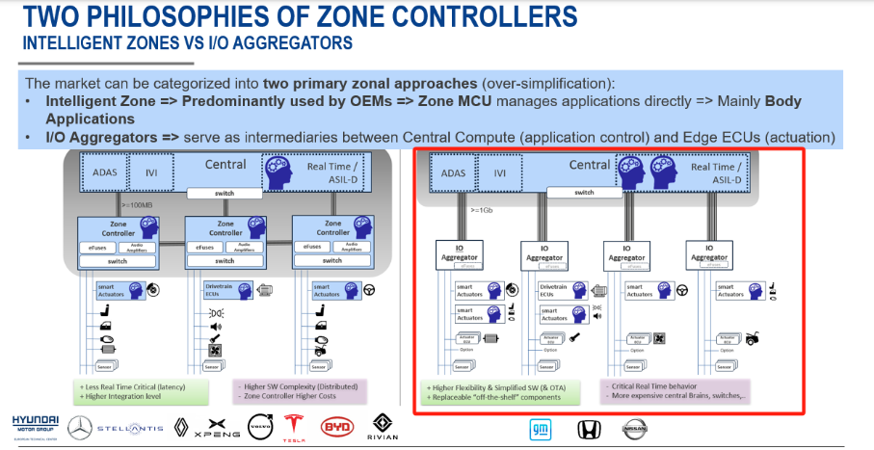

Figure 2:
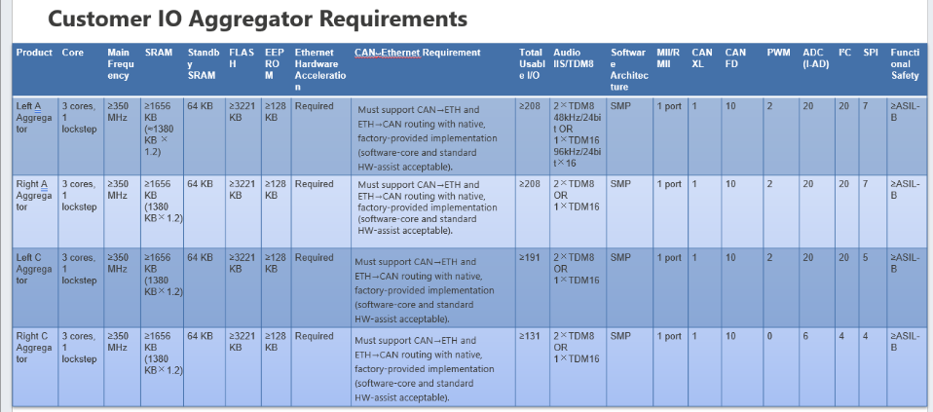

Best regards,
Vincent Lin;

